Lampasas Independent School District
School Nutrition Department
207 E. Ave. A, Lampasas, TX 76550 (512) 556-8948

Food Allergy or Medical Dietary Substitution Request Form
Alergia a los alimentos o formulario de solicitud médica de sustitución dietética

If your student has been diagnosed with a food allergy or has the need of a medical dietary substitution, complete this form, and return to the office of the Director of School Nutrition Services.

Si a su hijo se le ha diagnosticado alergia a los alimentos o si necesita una sustitucion dietetica medica, complete este formulario y envielo a la oficina del Director de Servicios de Nutrición Escolar.

Provide student information (información del estudiante):

Dietary Medical Concern: (Please indicate student’s special needs below.)
Preocupación médica dietética: (Por favor indique las necesidades especiales del estudiante a continuación.)

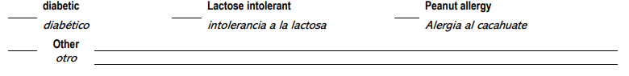
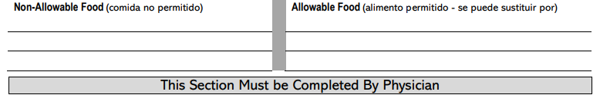
I certify that the above-named student needs to be offered food substitutes as described above because of the student’s food.
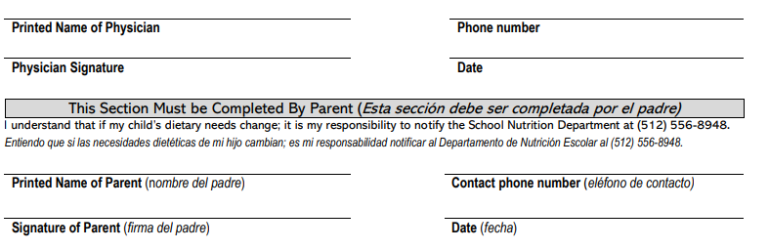

In accordance with federal civil rights law and U.S. Department of Agriculture (USDA) civil rights regulations and policies, this institution is prohibited from discriminating on the basis of race, color, national origin, sex (including gender identity and sexual orientation), disability, age, or reprisal or retaliation for prior civil rights activity. Program information may be made available in languages other than English. Persons with disabilities who require alternative means of communication to obtain program information (e.g., Braille, large print, audiotape, American Sign Language), should contact the responsible state or local agency that administers the program or USDA’s TARGET Center at (202) 720-2600 (voice and TTY) or contact USDA through the Federal Relay Service at (800) 877-8339. To file a program discrimination complaint, a Complainant should complete a Form AD-3027, USDA Program Discrimination Complaint Form which can be obtained online at: https://www.usda.gov/sites/default/files/documents/ad-3027.pdf, from any USDA office, by calling (866) 632-9992, or by writing a letter addressed to USDA. The letter must contain the complainant’s name, address, telephone number, and a written description of the alleged discriminatory action in sufficient detail to inform the Assistant Secretary for Civil Rights (ASCR) about the nature and date of an alleged civil rights violation. The completed AD-3027 form or letter must be submitted to USDA by: mail: U.S. Department of Agriculture Office of the Assistant Secretary for Civil Rights 1400 Independence Avenue, SW Washington, D.C. 20250-9410; or fax: (833) 256-1665 or (202) 690-7442; or email: Program.Intake@usda.gov This institution is an equal opportunity provider.

